# Install Virtual Box on Ubuntu –

## Method - 1

### Download the Virtual Box .deb file for Ubuntu and install –

1. Download the Oracle Virtual Box for > Ubuntu 14.04 from -  
   <http://download.virtualbox.org/virtualbox/5.0.4/virtualbox-5.0_5.0.4-102546~Ubuntu~trusty_amd64.deb>
2. Download Oracle Virtual Box for > Ubuntu 14.04 32 Bit from -  
   <http://download.virtualbox.org/virtualbox/5.0.4/virtualbox-5.0_5.0.4-102546~Ubuntu~trusty_i386.deb>
3. Ubuntu 12.04, 64 bit -  
   <http://download.virtualbox.org/virtualbox/5.0.4/virtualbox-5.0_5.0.4-102546~Ubuntu~precise_amd64.deb>
4. Ubuntu 12.04, 32 bit -  
   <http://download.virtualbox.org/virtualbox/5.0.4/virtualbox-5.0_5.0.4-102546~Ubuntu~precise_i386.deb>

Now “cd” to the directory where the above deb file has been downloaded –

user@machine$ cd Downloads/

user@machine$ sudo dpkg --install virtualbox-5.0_5.0.4-102546~Ubuntu~trusty_amd64.deb

## Method – 2

### Install using the apt-get utility of Ubuntu Linux. –

Add the following line to your /etc/apt/sources.list:

sudo gedit /etc/apt/sources.list  
deb http://download.virtualbox.org/virtualbox/debian vivid contrib

According to your distribution, replace 'vivid' by 'utopic', 'trusty', 'raring', 'quantal', 'precise', 'lucid', 'jessie', 'wheezy', or 'squeeze'.

**For 14.04 and above use trusty and for 12.04 use precise.**

The Oracle public key for apt-secure can be downloaded [here](https://www.virtualbox.org/download/oracle_vbox.asc). You can add this key with

sudo apt-key add oracle_vbox.asc

To install Virtual Box, do

sudo apt-get update

sudo apt-get install virtualbox-5.0

# Install Virtual Box on Windows –

## Install VirtualBox

Download the Oracle Virtual Box as per your windows architecture (32 bit/64 bit) from here –

<http://download.virtualbox.org/virtualbox/5.0.4/VirtualBox-5.0.4-102546-Win.exe>

Installation is straight forward and wizard based, you can choose the select the default options.

## Install Extension Pack

Download the extension pack from –

<http://download.virtualbox.org/virtualbox/5.0.4/Oracle_VM_VirtualBox_Extension_Pack-5.0.4-102546.vbox-extpack>

## Load extension pack in VirtualBox

Open the VirtualBox and open preferences –

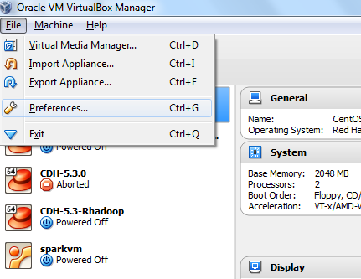

Go to the extensions tab in the preferences and add the package (optional) –

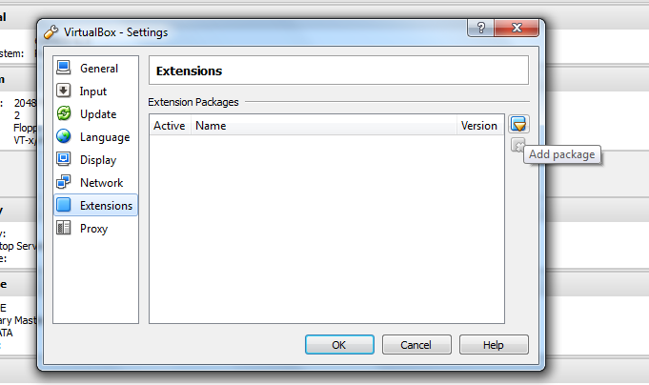

# Get Cloudera Hadoop Distribution –

Get the quick start VM from here –

<http://www.cloudera.com/content/cloudera/en/downloads/quickstart_vms/cdh-5-4-x.html>

1. Let the version be 5.4.x
2. Download for VirtualBox
3. Extract with 7z

# Start CDH with VirtualBox –

Open VirtualBox and click New –

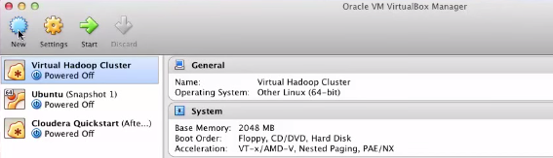

Fill in the new VM details –

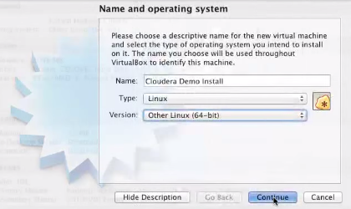

Allocate enough memory to the VM –

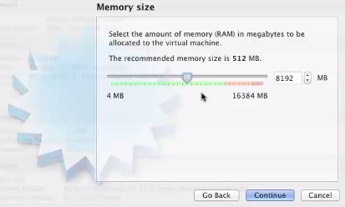

Associate the VDI we have downloaded from cloudera –

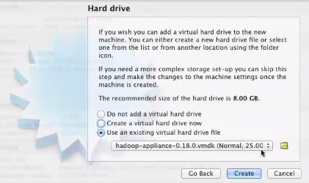

Using the small arrow after hadoop-applian…. browse through the .vmdk file in the extracted folder of cloudera and press create.

Right click the newly created VM and select settings.

In the General tab, select the advanced option and change as below (leave the Snapshot Folder option as it is) –

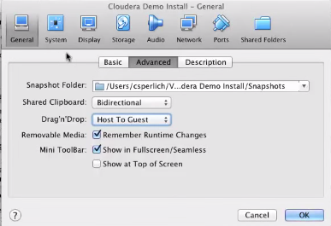

Change the processors to –

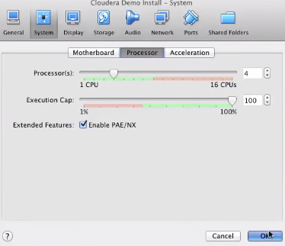

Finally from the list of VMs in the left hand side, select the cloudera one and press start.

Pre-requisites –

1. You need to enable the virtualization on your host machine through bios settings.